ONLINE PAYMENT FRAUD DETECTION USING MACHINE LEARNING
Project Description
One of the most important aspects affecting the global economy and financial stability is online digital payments. With the rapid growth of online transactions through UPI, cards, and net banking, fraudulent activities have also increased significantly. Banks and financial institutions face serious challenges in detecting fraudulent transactions and minimizing financial loss.
Fraud detection is a complex task because fraud patterns change frequently and traditional rule-based systems fail to detect new attacks. By using machine learning algorithms, we can analyze transaction behavior and identify suspicious patterns automatically.
In this project, Online Payment Fraud Detection, we apply classification algorithms such as:
- Logistic Regression
- Random Forest
- Decision Tree
- XGBoost
The best performing model is saved in .pkl format and integrated into a Flask web application to provide real-time fraud prediction.

Technical Architecture:
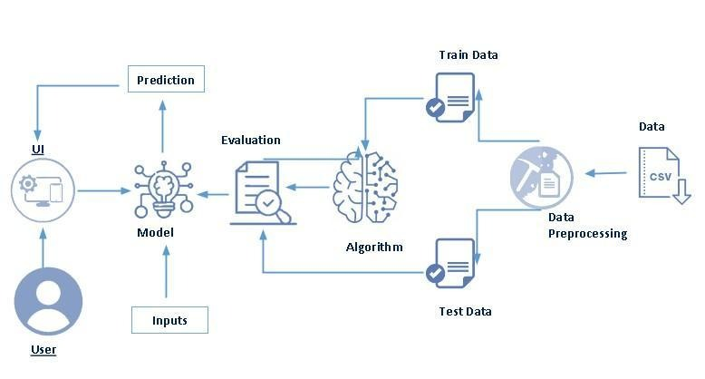

User → Web Interface → Flask Server → ML Model → Fraud Prediction → Result Display

Pre-Requisites
Software Required
- Anaconda Navigator
- Python
- VS Code / PyCharm
- Refer the link below to download anaconda navigator
- Link : https://youtu.be/1ra4zH2G4o0

Python Packages
Install using Anaconda Prompt:
pip install numpy
pip install pandas
pip install scikit-learn
pip install matplotlib
pip install seaborn
pip install flask
pip install pickle-mixin

Prior Knowledge
You must have prior knowledge of following topics to complete this project.
- ML Concepts
- Supervised learning: https://www.javatpoint.com/supervised-machine-learning
- Unsupervised learning: https://www.javatpoint.com/unsupervised-machine-learning
- Regression and classification
- Decision tree: https://www.javatpoint.com/machine-learning-decision-tree-classification-algorithm
- Random forest: https://www.javatpoint.com/machine-learning-random-forest-algorithm
- KNN: https://www.javatpoint.com/k-nearest-neighbor-algorithm-for-machine-learning
- Xgboost: https://www.analyticsvidhya.com/blog/2018/09/an-end-to-end-guide-to-understand-the-math-behind-xgboost/
- Evaluation metrics: https://www.analyticsvidhya.com/blog/2019/08/11-important-model-evaluation-error-metrics/
Flask Basics : https://www.youtube.com/watch?v=lj4I_CvBnt0
Project Objectives:
By the end of this project you will:
- Know fundamental concepts and techniques used for machine learning.
- Gain a broad understanding about data.
- Have knowledge on pre-processing the data/transformation techniques on outlier and some visualization concepts.
Project Flow:
- User interacts with the UI to enter the input.
- Entered input is analyzed by the model which is integrated.
- Once model analyses the input the prediction is showcased on the UI

To accomplish this, we have to complete all the activities listed below,
- Data collection
  - Collect the dataset or create the dataset
- Visualizing and analyzing data
- Univariate analysis
- Bivariate analysis
- Multivariate analysis
- Descriptive analysis
- Data pre-processing
  - Checking for null values
  - Handling outlier
  - Handling categorical data
  - Splitting data into train and test
- Model building
  - Import the model building libraries
  - Initializing the model
  - Training and testing the model
  - Evaluating performance of model
  - Save the model
- Application Building
  - Create an HTML file
  - Build python code

Project Structure:
Create the Project folder which contains files as shown below
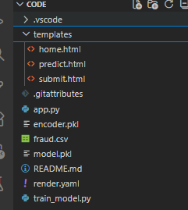
- We are building a flask application which needs HTML pages stored in the templates folder and a python script app.py for scripting.
- rdf.pkl is our saved model. Further we will use this model for flask integration.
- Training folder contains model training files and training_ibm folder contains IBM deployment files.
PROJECT MILESTONES
Milestone 1: Data Collection
Fraud detection heavily depends on transaction data. We used a real online payment fraud dataset containing:
- Transaction amount
- Sender and receiver balances
- Transaction type
- Fraud label
The dataset was taken from Kaggle / financial transaction datasets.
Link: https://www.kaggle.com/datasets/rupakroy/online-payments-fraud-detection-datasethttps://www.kaggle.com/datasets/rupakroy/online-payments-fraud-detection-dataset

Milestone 2: Data Visualization and Analysis
Univariate Analysis
- Distribution of transaction amount
- Count of transaction types
Bivariate Analysis
- Transaction type vs fraud
- Amount vs fraud
Multivariate Analysis
- Relationship between balances, amount and fraud
- Activity 1: Importing the libraries
- Import the necessary libraries as shown in the image. (optional) Here we have used visualization style as fivethirtyeight.
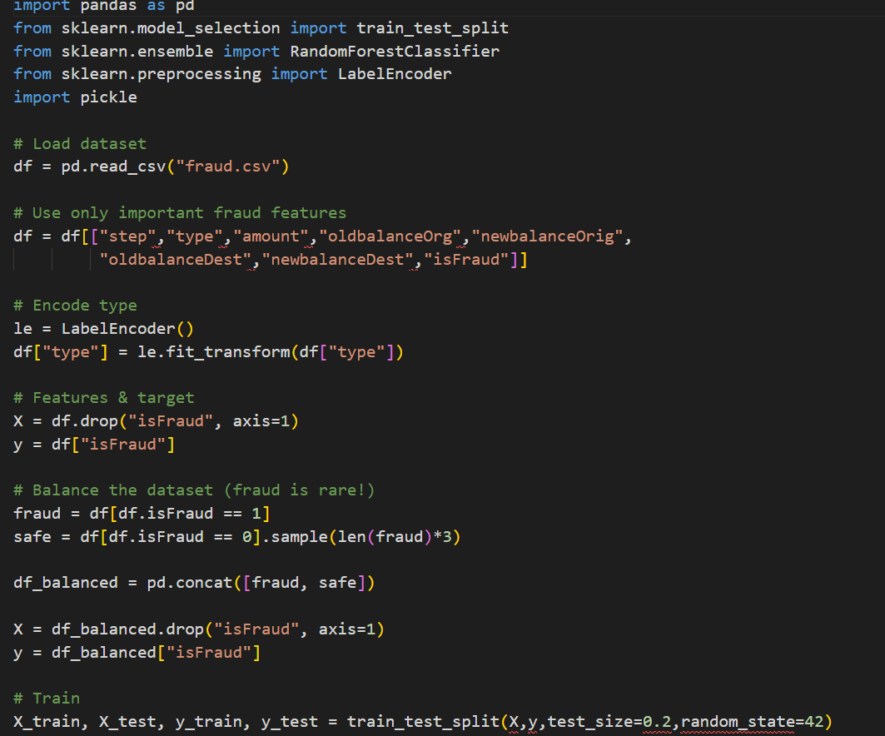
- Activity 2: Read the Dataset
- Our dataset format might be in .csv, excel files, .txt, .json, etc. We can read the dataset with the help of pandas.
- In pandas we have a function called read_csv() to read the dataset. As a parameter we have to give the directory of csv file.
- Activity 3: Univariate analysis
- In simple words, univariate analysis is understanding the data with single feature. Here we have displayed two different graphs such as distplot and countplot.

Descriptive Analysis
Used describe() to get:
- Mean
- Max
- Min
- Standard deviation
Milestone 3: Data Pre-Processing
Steps Performed
- Checking missing values
- Encoding categorical variables
- Scaling numeric values
- Balancing dataset
- Train-test split
Handling Categorical Data
Transaction type (PAYMENT, TRANSFER, CASH_OUT, etc.) is encoded numerically.
Balancing Dataset
Fraud data is highly imbalanced.
We use SMOTE to balance fraud and non-fraud records.
Train-Test Split
80% training data
20% testing data
Milestone 4: Model Building
Algorithms Used
1. Logistic Regression
Logistic Regression is a widely used statistical model for binary classification problems. It estimates the probability that a transaction belongs to a fraudulent or non-fraudulent class based on input features such as transaction amount, balances, and transaction type.
2. Decision Tree
Decision Tree is a supervised learning algorithm that splits data into branches based on feature values. It creates a tree-like structure that helps in making decisions by following a sequence of conditions. This model is easy to interpret and performs well on structured transaction data.
3. Random Forest
Random Forest is an ensemble learning method that combines multiple decision trees to improve prediction accuracy. It reduces overfitting and increases model stability by averaging the results of several trees, making it highly effective for fraud detection.
4. XGBoost
XGBoost (Extreme Gradient Boosting) is an advanced and powerful boosting algorithm. It builds models sequentially and focuses on correcting errors made by previous models. XGBoost provides high accuracy and handles complex fraud patterns efficiently.
Model Evaluation Metrics
Each model was trained and tested using the same dataset. Their performance was evaluated using the following metrics:
Accuracy
Accuracy measures the percentage of correctly classified transactions. It shows how well the model predicts both fraud and non-fraud cases.
Confusion Matrix
The confusion matrix displays:
- True Positives (correctly predicted frauds)
- True Negatives (correctly predicted safe transactions)
- False Positives (safe transactions predicted as fraud)
- False Negatives (fraud predicted as safe)
The best performing model is selected and saved as model.pkl.
Milestone 5: Application Building
HTML Pages
Three HTML files are created:
home.html
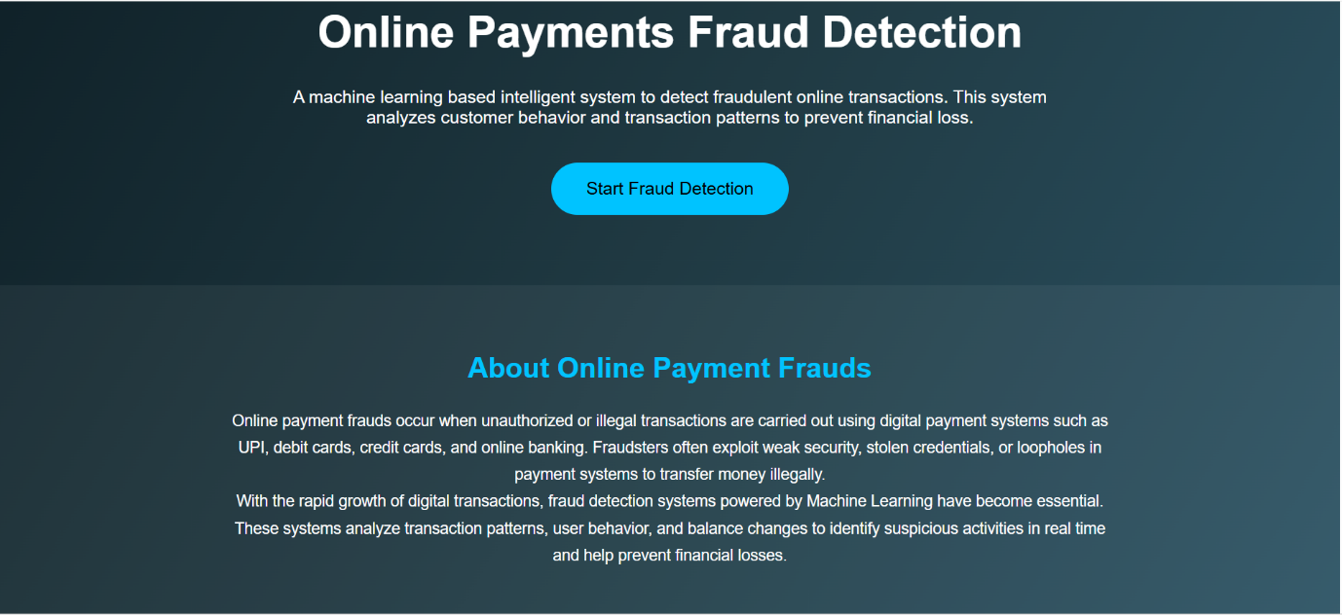
predict.html
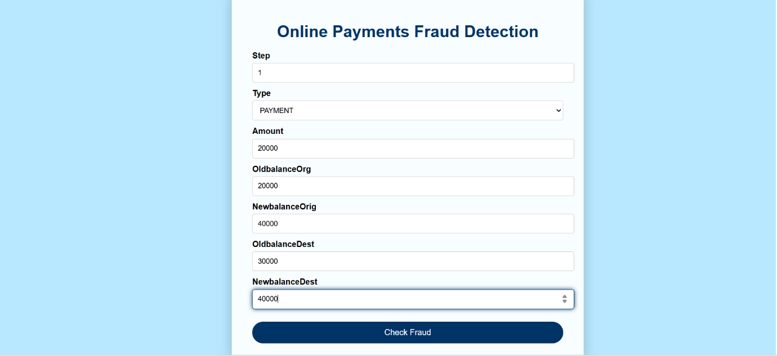
submit.html

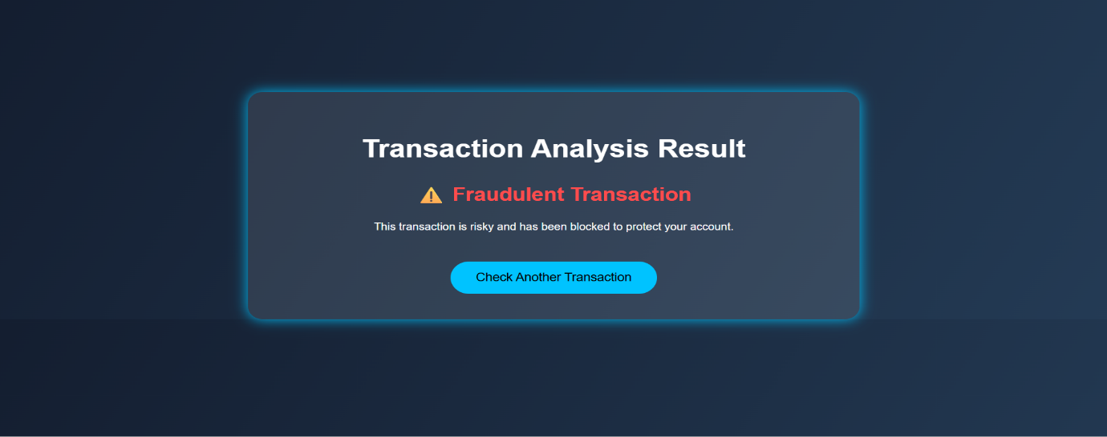

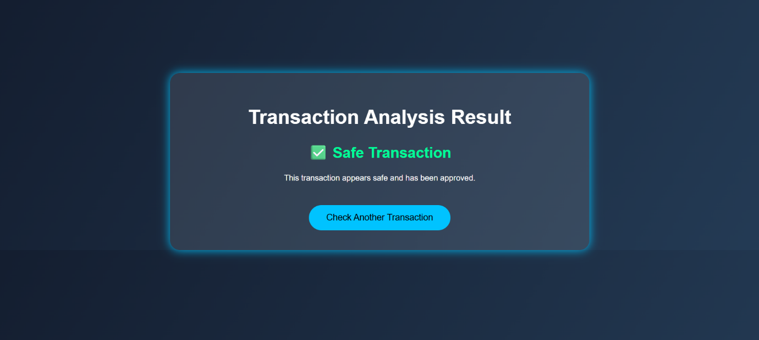
Stored in the templates folder.
Flask Backend
The Flask application:
- Loads the trained model
- Accepts input from HTML form
- Passes values to ML model
- Displays Fraud or Safe result
Running the Application
- Open Anaconda Prompt
- Navigate to project folder
- Run:
python app.py
- Open browser and go to:
http://127.0.0.1:5000
- Enter transaction details and click Check Fraud
Results
The system successfully predicts:
- Fraudulent transactions
- Safe transactions
It provides instant and accurate results through the web interface.
Conclusion
The Online Payment Fraud Detection System is an effective machine learning-based solution for identifying suspicious transactions. It helps banks and users reduce financial losses and improve digital payment security.
Future Scope
- Real-time bank API integration
- Mobile application
- Deep learning models
- Admin fraud dashboard
- Cloud deployment

